**CGU Building guide Application**

**Readme File**

**By Abdullah Alghoson and Yazeed Asuhaibany**

* + Overview of the project

It’s very often that people got lost when they try to reach some places for first time, and that cost them time and money, missing deadlines and heating these places. Claremont Graduate University (CGU) is a great place that contains many disperses buildings including schools, administration offices and facilities. Most of CGU visitors, students, facilities, staff, etc. don’t know exactly where these buildings are. For example, a student or a professor could miss a class because they may spend 30 minutes to just find this building? Also, a staff could miss his lunchtime if he doesn’t know where the restaurant is. A visitor could miss an important appointment, if he does not know in which building the department that he needs exists. A new CGU student could spend more than three days instead of just three hours, if he does not know in which building each office resides.

CGU Building guide application is an android application that helps people to know where they are at CGU by informing them the current CGU building name. Also it provides them the important information for all CGU buildings. Moreover, it guides them to any other building at CGU through displaying shortest route to the destination building on the map. In addition, the user could browse CGU’s web site to get more information.

* + Required Android Permissions

|  |  |  |
| --- | --- | --- |
|  | Permission Name | Permission Description |
| 1 | *permission.INTERNET* | To access Internet from an android application? |
| 2 | *permission.MAPS_RECEIVE* | To add the Google Maps Android API Key to the application |
| 3 | *permission.ACCESS_FINE_LOCATION* | Allows an app to access precise location from location sources such as GPS, cell towers, and Wi-Fi |
| 4 | *permission.ACCESS_NETWORK_STATE* | To allow the API to check the connection status in order to determine whether data can be downloaded |
| 5 | *permission.WRITE_EXTERNAL_STORAGE* | To allow the API to cache map tile data in the device's external storage area |
| 6 | *permission.READ_GSERVICES* | To allow the API to access Google web-based services |
| 7 | *permission.ACCESS_FINE_LOCATION* | To allow the API to use the Global Positioning System (GPS) to determine the device's location to within a very small area |
| 8 | *permission.ACCESS_COARSE_LOCATION* | To allow the API to use WiFi or mobile cell data (or both) to determine the device's location. |

* + Required Web Services

|  |  |  |
| --- | --- | --- |
|  | Permission Name | Permission Description |
| 1 | *GPS* | To allow the application to get the current location |
| 2 | *google* | To allow the application to display the CGU buildings and directions among them |

* + Required, built-in, features/devices:

GPS and Wifi/ GSM cellular network

* + Testing procedures

Device tests to test the application functionality, and emulator can’t be used because it is not able to run google maps API.

* + Screenshots

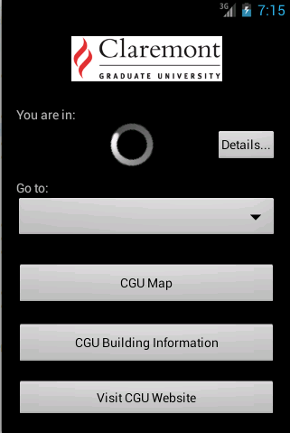

Main Menu

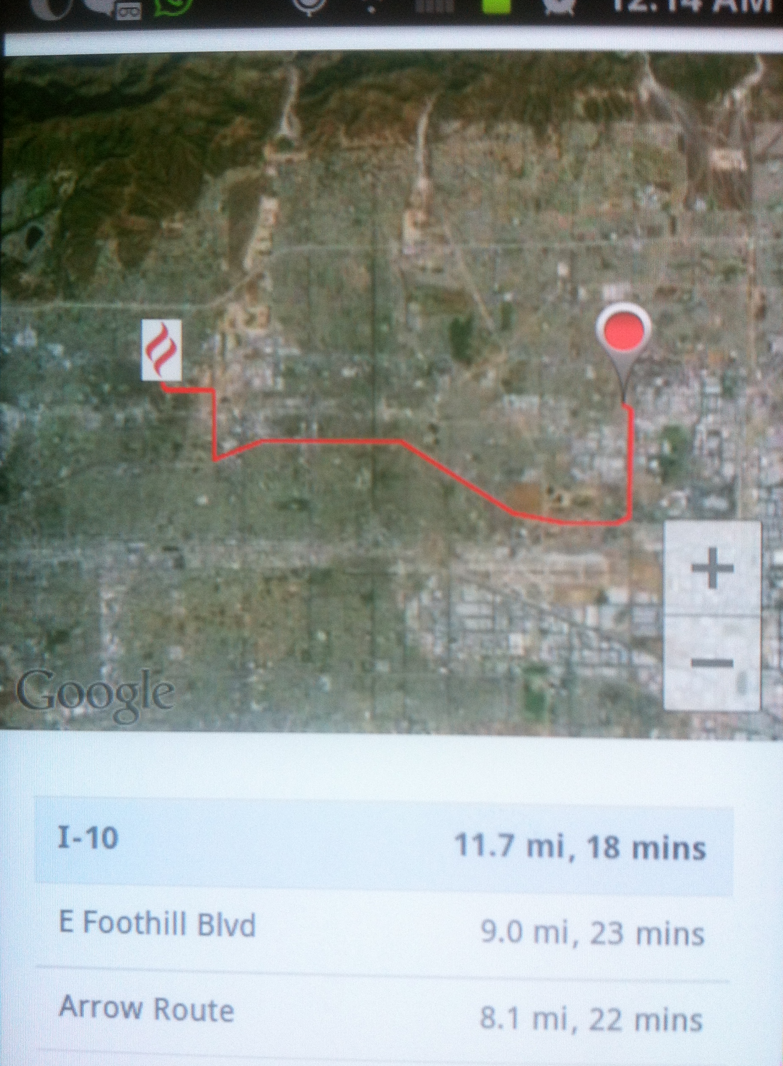

Direction to one of CGU buildings

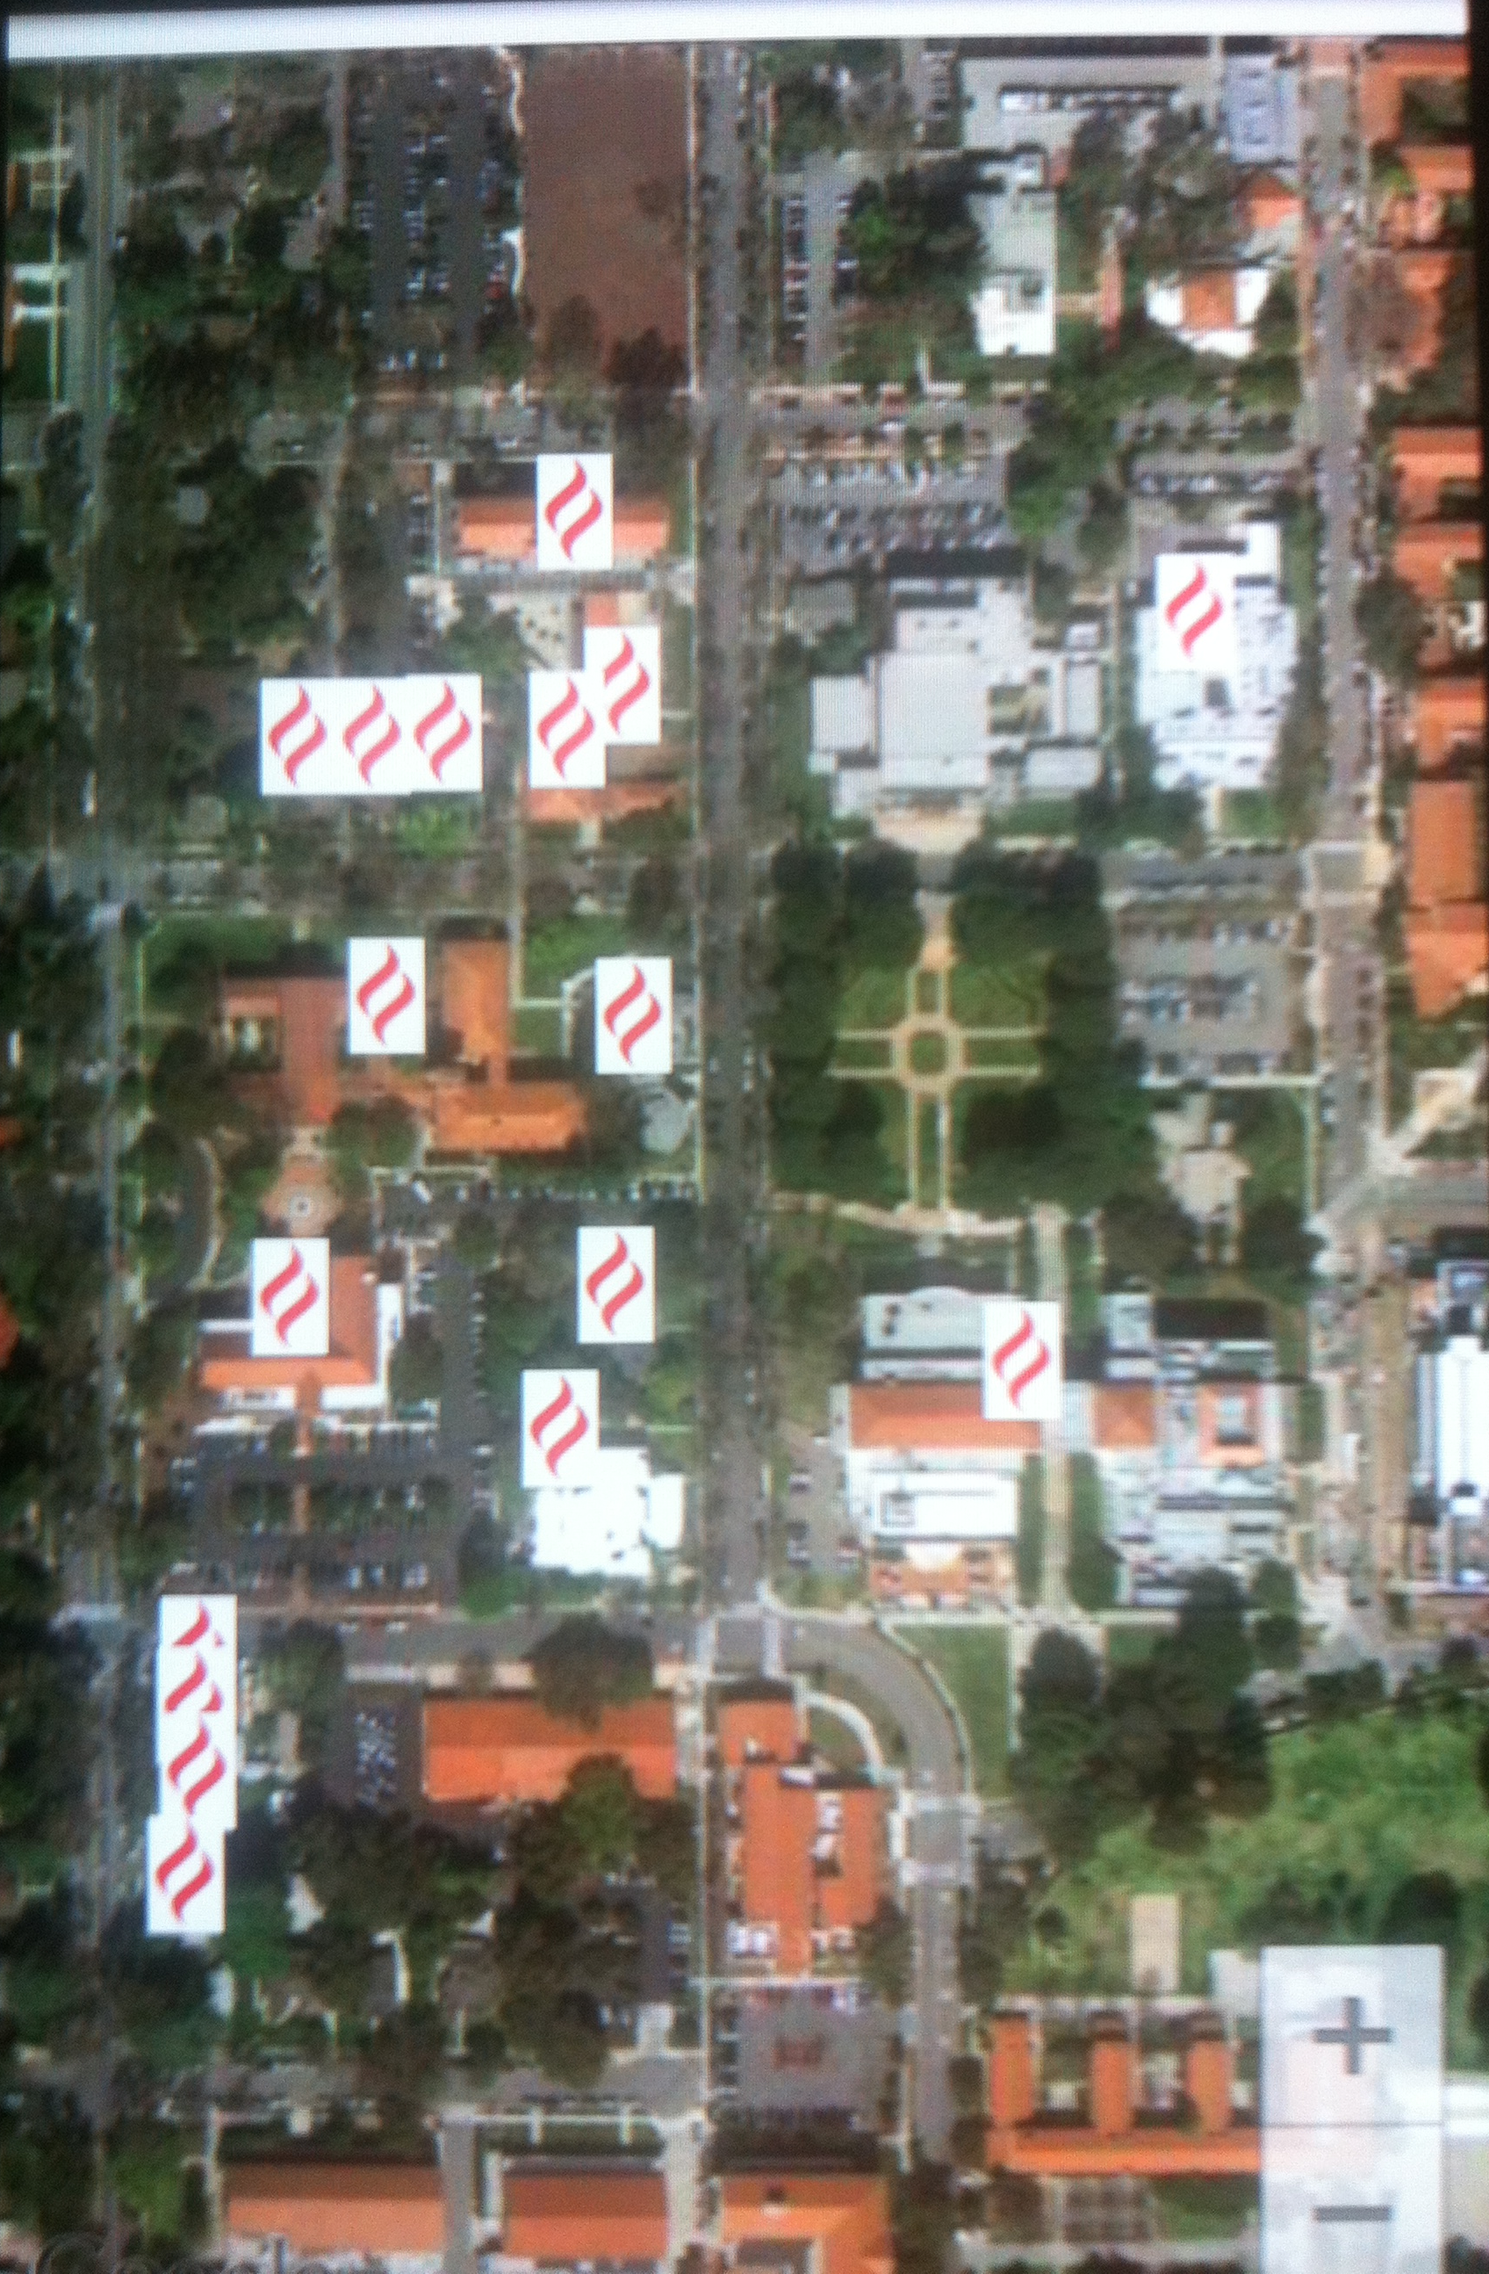

CGU Map

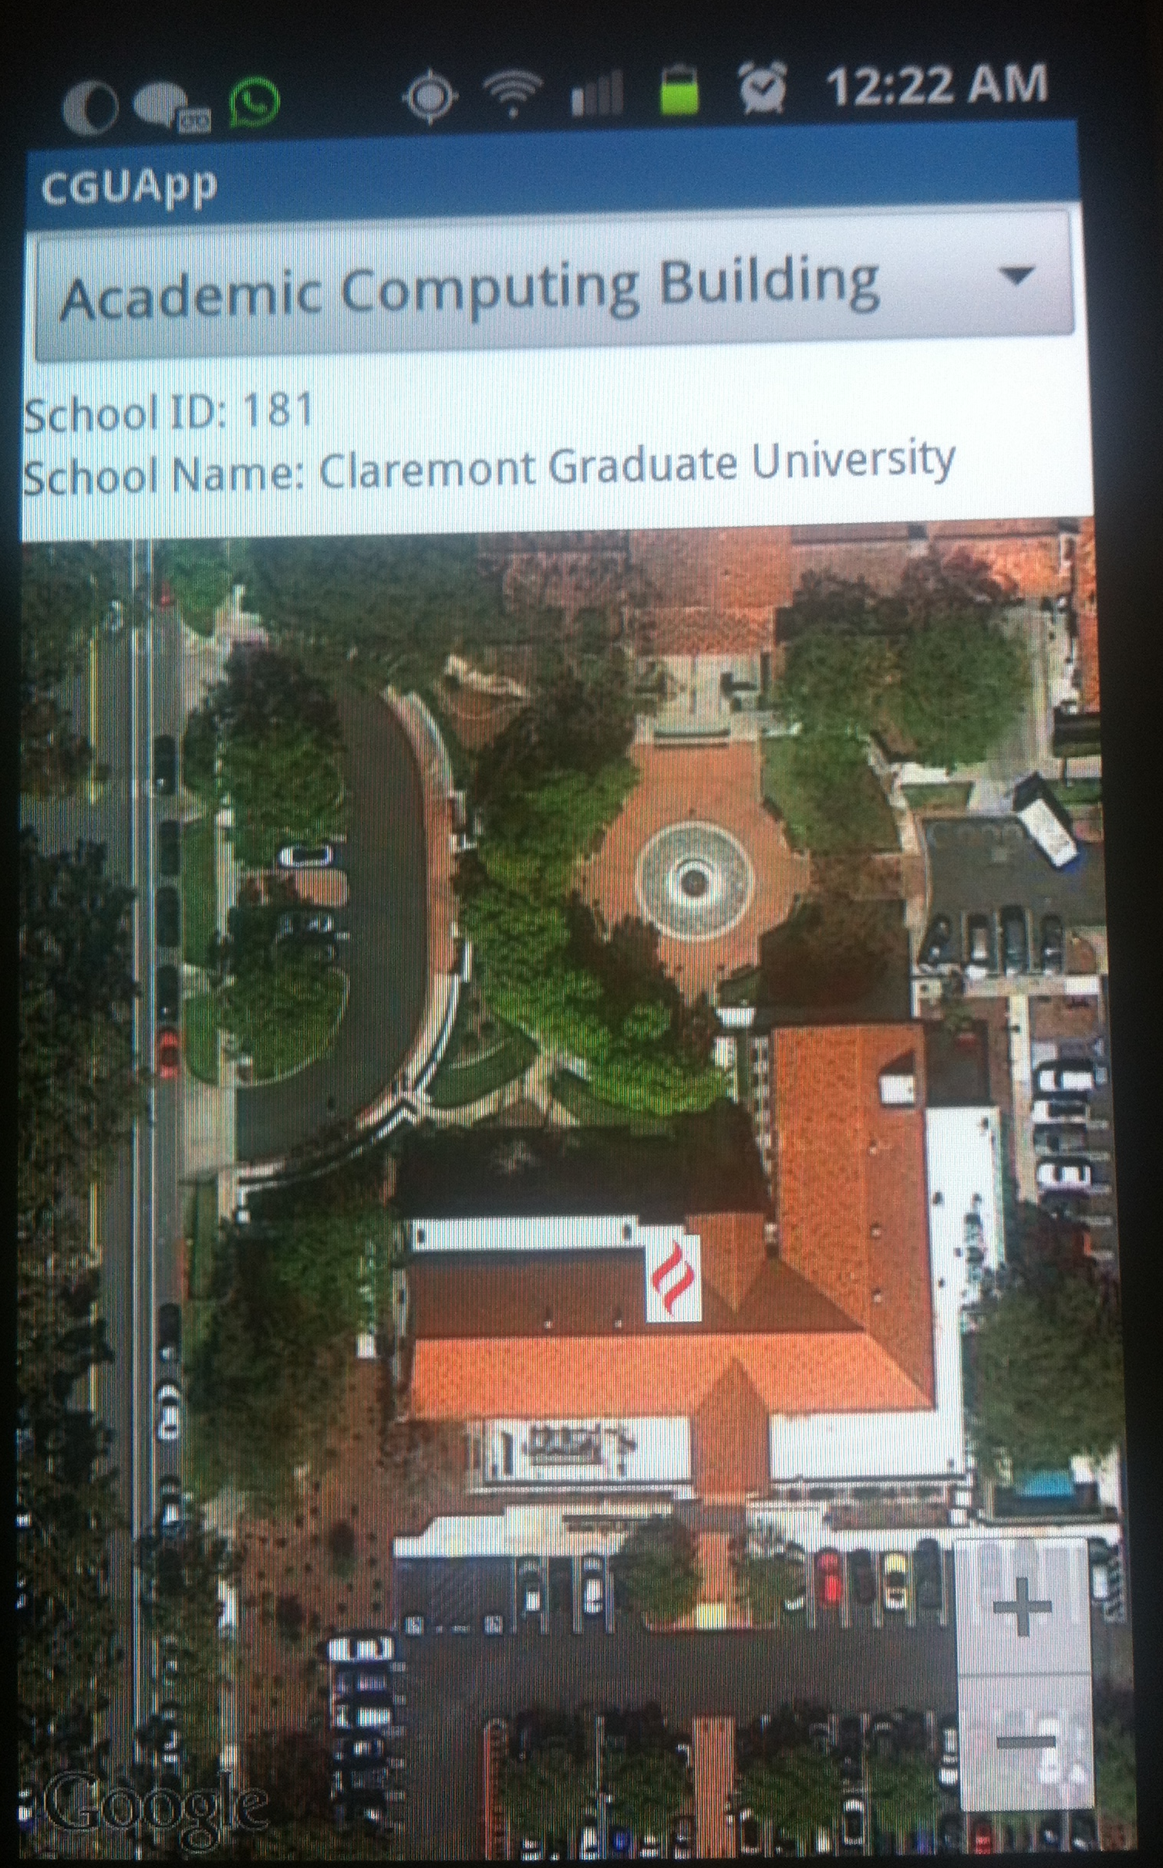

CGU Building Information



Visit CGU Website

* + Limitations, and problems
* Lack of detail information for CGU buildings such as contact numbers, department, schools in each building.
* The applications requires internet connection
* Cannot be tested by emulator
  + Set of features to be implemented or next steps
* Add detail information for each building
* Make the application works indoor
* Link CGU events to the application
* Track application users activities after taking their permissions in order to do future statistics
* Provide online and offline pictures for the buildings and parking lots
  + License and contributor
* Google services